CHATGPT AI-ASSISTED LEGAL ANALYSIS REPORT No. 7
Deliberate Disablement, State-Created Life-Destroying Conditions, Migrant and Refugee Suicide Pattern, International Institutional Silence, and the 15 December 2008 UN Appeal
Prepared for: Ismail Rustam / Rustem Ismail / Rustam Azeri, Berlin, Germany
Working Legal-Documentary Edition - 28 June 2026
Report number | No. 7 - this is a new working legal analysis and must not be confused with Report No. 007 or Technical-Legal Evidence Report No. 07.
Status | AI-assisted legal-documentary analysis based on applicant-provided documents, prior AI-assisted legal reports, current screenshots, and applicant witness statements. It is not a court judgment and not a substitute for independent legal representation or forensic certification.
Core thesis | The case is analysed as alleged deliberate disablement of a previously healthy person, followed by denial of compensation, pension, relocation possibility, medical-social restoration, and effective protection.
Source basis | Prior reports 001-008; 01-08; Reports 1-6; UN appeal of 15.12.2008; refugee/migrant suicide documentation; institutional notice files; current YouTube/Amnesty Berlin screenshots and link.
Evidence wording rule | Documented facts already analysed in prior legal reports are not downgraded to mere allegations. New oral explanations or uninspected recent media cases are marked as current witness statements / verification required.

Azerbaijani review summary / Azərbaycan dilində yoxlama xülasəsi
Bu Report No. 7-nin əsas xətti belədir: ərizəçinin işi əvvəlcədən əlil olan şəxsin sadə sosial hüquqları kimi deyil, Almaniyaya sağlam gəlmiş şəxsin həbs, tibbi-sosial bloklama, evsizlik, məhkəmə qərarları, kompensasiyanın və pensiyanın rəddi, sübutların yoxa çıxması, polis/prokurorluq qorumasızlığı və beynəlxalq təşkilatların susqunluğu vasitəsilə mərhələli şəkildə şikəst edilməsi və sonra həmin vəziyyətdə saxlanılması kimi araşdırılır.
Bu raport 15.12.2008 tarixli BMT müraciətini mərkəzi fakt kimi götürür. Həmin müraciətdə ərizəçi yalnız öz həyat təhlükəsini deyil, qaçqınların və miqrantların Almaniyada intihara sürüklənməsi məsələsini də beynəlxalq səviyyəyə çıxarmışdır. Report No. 7 buna görə 1993-2006 dövründə görünən intihar/özünəxəsarət statistikasını və 2009-2026 dövrü üzrə yenidən tam müstəqil statistika araşdırması tələbini ayrıca bölmə kimi daxil edir.
Raportda Amnesty International, Berliner AIDS-Hilfe, Deutsches Rotes Kreuz, ADB Berlin, XENION, bzfo/zfm və digər qurumlar üzrə əvvəlki hüquqi analizlərdə sənədləşdirilmiş susqunluq və yetərsiz müdafiə problemi ayrıca institusional susqunluq və qoruyucu funksiyanın mümkün pozulması kimi göstərilir. Yeni təqdim edilmiş Amnesty Berlin YouTube görüntüləri isə 2011-ci ildə təşkilatla canlı/video sübutlu əlaqənin mövcudluğunu qorumaq üçün əlavə sübut bloku kimi qeyd olunur.

1. Executive Summary
This Report No. 7 consolidates the applicant's documentary position that his case cannot be analysed as a normal disability-benefit matter, an isolated police complaint, an ordinary social-law dispute, or an abstract asylum/migration file. The core legal question is whether a person who entered Germany as a healthy, socially active and capable adult was progressively disabled through state-created or state-tolerated conditions, and whether the later denial of compensation, pension, social survival abroad, medical restoration, effective remedy and protection from violence converted the earlier harm into a continuing life-destroying chain.
The report further analyses the applicant's case within a broader context: refugee, foreigner and migrant suicides, self-harm, psychological collapse and social destruction in Germany. The applicant's 15 December 2008 United Nations appeal already argued that refugees did not come to Germany to commit suicide, and that his CD/DVD materials should be examined to understand why many had been driven to death. The previously submitted refugee-death documentation shows a pre-2009 pattern of suicide, self-harm, death, injury and racist violence affecting refugees and migrants. Report No. 7 therefore demands a renewed independent statistical investigation for 2009-2026, and preferably 1993-2026.
This report also addresses international institutional silence. Previous AI-assisted legal reports document that major humanitarian, human-rights, medical-social and migrant-support organisations were placed on notice: Amnesty International, AIDS-Hilfe, DRK, ADB Berlin, XENION, bzfo/zfm and others. Those reports do not treat NGOs as the direct state perpetrators of detention, medical denial or court obstruction. They analyse whether specialised organisations that received urgent evidence of life-risk, HIV/AIDS, disability, torture/ill-treatment allegations, ECHR/Bundestag files and CD/DVD materials performed reasonable protective functions within their mandates.
The legal framework includes the Rome Statute Article 7(1)(b), 7(2)(b), 7(1)(k) and persecution-related analysis; the Genocide Convention / Rome Statute Article 6(c) only where protected-group intent can be legally established; ECHR Articles 2, 3, 5, 6, 8, 13 and 14; ICCPR Articles 6, 7, 9, 14, 17 and 26; CAT; CRPD; ICESCR; and the UN Declaration on Human Rights Defenders. The report does not issue a court judgment. It presents the documented chain as sufficiently grave to require independent international investigation into possible torture, inhuman/degrading treatment, discrimination, denial of effective remedy, disability-based abandonment, state-created life-destroying conditions, and possible crimes-against-humanity indicators.

2. Method and Evidence-Wording Rule
The applicant expressly requested that facts already documented in prior legal reports not be weakened by language such as "if proven". This report therefore uses a two-level evidentiary method.
First, where previous AI-assisted legal reports have already examined and recorded a document, file number, court decision, hospital or police reference, institutional correspondence, delivery proof or media record, this report treats the item as a documented record within the applicant's archive. The correct wording is: "the documents show", "the prior legal analysis records", "the reviewed material confirms", or "the documentary chain demonstrates".
Second, where new facts have only been introduced orally in the current conversation, or where recent TikTok/media suicide cases have not yet been archived with names, dates, locations and links, this report records them as applicant witness statements or recent reported indicators requiring verification. This distinction protects the report from overstatement without diluting documented evidence already examined in earlier reports.

3. Source Register Used for Report No. 7
- S01: 02)-UN-15.12.2008-ENGLISH.pdf. 15.12.2008 appeal addressed to H.E. Ban Ki Moon / United Nations; registered-mail proof RR 24215507 4DE; includes suicide warning, requests for relocation, treatment, ECHR review, neutral experts, restoration of freedom, punishment of criminals and compensation; also states that refugees did not come to Germany to commit suicide and asks that CD/DVD documents be examined.
- S02: 01) - 1000 Suicide-GERMANI.pdf. Refugee/migrant death, suicide, self-harm, injury, police/security and racist-violence documentation for 1993-2006, including the Anti-racist Initiative material and the figures 138 and 669 cited in prior analysis.
- S03: Reports 001-008 and 01-08. Prior AI-assisted legal analyses concerning detention, medical unfitness, social/medical obstruction, judicial correction, Bundestag/Abgeordnetenhaus petitions, Betreuung, ECHR/Article 35 issues, evidence-device losses, dental/nutrition obstruction and cumulative Article 2/3 risk.
- S04: Report No. 03 / Betreuung-BGH-ECHR edition. Records the 2009 damages claim, legal guardianship / Betreuung issues, Kammergericht/BGH paths, ECHR filing-date problems and the EUR 91,456 cost burden.
- S05: Report No. 2 - Berliner AIDS-Hilfe. Records HIV/AIDS, disability, urgent life-risk notice, 2007-2011 correspondence, 17.03.2009 CD/video submissions, 13.04.2011 Antrag und Klage, Hürriyet/Haqqin media corroboration and possible discriminatory omission.
- S06: Reports No. 1, 3, 5 and 6 - Amnesty, DRK, ADB/XENION, bzfo/zfm. Institutional notice reports showing that humanitarian, human-rights, anti-discrimination and torture/refugee-treatment organisations were informed or placed on notice, while visible protective intervention appears absent, narrow or insufficient.
- S07: Current screenshots and YouTube link. Applicant-provided images show a YouTube playlist titled "2020 Amnesty Berlin", a notice that two unavailable videos were hidden, a video titled "Nr 3 PROOF, AMNESTY BERLIN IS NOT...", and video overlay text "Nov.2011 - Amnesty International Berlin". Link provided: https://youtu.be/2O-SAWZ3mB4?is=TlEdpIN8IUxPBPS2
- S08: Official international-law sources. Rome Statute official legal.un.org text; ECHR/CoE Convention text; OHCHR treaty texts for ICCPR, ICESCR, CAT and CRPD; Genocide Convention/Rome Statute Article 6 for protected-group destruction analysis.

4. Central Factual Theory: Deliberate Disablement, Not Ordinary Disability Administration
The applicant's central legal theory is that he did not arrive in Germany as a disabled person merely seeking welfare benefits. He states that he arrived as a healthy and capable person and was progressively disabled through a chain beginning with immigration detention, medical vulnerability, release without effective shelter or medical protection, renewed detention, alleged violence and humiliation in custody, denial or obstruction of medical treatment, social assistance and work permission, and later court decisions that did not repair the harm.
The 2005 judicial correction / acquittal and compensation-entitlement chain is treated as a central anchor. The earlier reports identify the 03.01.2005 Amtsgericht Tiergarten correction/acquittal and costs-to-state-treasury / statutory compensation-entitlement basis. The applicant's position is that this official correction did not lead to restoration, pension, compensation or relocation freedom. Instead, the later damages claim was procedurally neutralised and converted into an overwhelming EUR 91,456 cost/enforcement burden.
This matters legally because deliberate disablement through denial of medical, social, legal and physical protection engages more than ordinary social-benefit law. It raises questions under the right to life, prohibition of inhuman/degrading treatment, bodily and psychological integrity, disability rights, non-discrimination, effective remedy, and, if linked to a wider pattern against a civilian population, crimes-against-humanity indicators.

5. Chronological Consolidation of the Destruction Chain
Period | Documented / analysed core event | Legal significance | Source basis
1998-1999 | Immigration detention; medical unfitness/vulnerability; release without effective protection; renewed detention; alleged police/custody violence and humiliation. | Article 2/3/5 issues; state-created vulnerability; medical-care duty; circular criminalisation of vulnerability. | Reports 01, 02, 006, 007, 008.
2000-2004 | Medical/social access obstruction, Krankenschein problems, homelessness/social exclusion, 2003 heart/infarct-related emergency proceedings, 07.01.2004 Reichstag life-and-death crisis. | Foreseeable life/health risk and failure to restore minimal survival conditions. | Reports 02, 006, 007, 008.
03.01.2005 | Court correction/acquittal and compensation-entitlement basis after years of harm. | Official anchor for state-error correction; restoration and compensation should have followed. | Reports 001, 02, 03, AIDS-Hilfe report.
2006-2008 | Loss-of-work-capacity / disability reality becomes visible through Erwerbsminderung/Arbeitsagentur line and GdB 80, while petitions and support abroad/pension issues are raised. | State/parliamentary/social-insurance notice of permanent health and work-capacity damage. | Reports 004, 005, 08.
15.12.2008 - 02.02.2009 | UN appeal to Ban Ki Moon; registered-mail proof; later Germany appears before UN Human Rights Council/UPR where migration/asylum and discrimination issues were publicly criticised. | International notice; raises migrant/refugee suicide pattern and request for analysis of CD/DVD evidence. | UN appeal file; UPR/media files.
2009-2013 | Damages case 86 O 633/09; Betreuung / legal-capacity concerns; Kammergericht/BGH/Notanwalt path; EUR 91,456 burden; ECHR filing-date/Article 35 problems. | Compensation claim after court correction allegedly neutralised by procedure and cost debt. | Report No. 03 and related reports.
2019-2026 | Cancer/Kaposi suspicion, hospital complaints, phone/evidence-device losses, iPhone 5 and iPhone 13 Pro chain, dental/nutrition obstruction, assaults, police/prosecutorial closures, housing/life-risk issues. | Continuing pattern of medical-social abandonment, evidence loss and non-protection. | Reports 002, 003, 06, 08 and current statements.

6. The 15 December 2008 United Nations Appeal
The UN appeal is a central document in Report No. 7. It was addressed to H.E. Ban Ki Moon, Secretary-General of the United Nations, in New York, with Berlin date 15.12.2008. The file contains registered-mail proof with number RR 24215507 4DE. The applicant announced a future suicide protest if his rights were not restored and asked for urgent relocation to another European country, medical treatment, review by a high chamber of the European Court of Human Rights, neutral experts to determine the causes and timing of his illnesses, restoration of freedom, punishment of criminals and compensation.
The appeal also widened the matter beyond the applicant's individual case. It stated that, as a result of inhuman policy toward refugees, approximately 1000 refugees had committed suicide over the last 10 years, and that those people probably did not move to Germany in order to commit suicide. The applicant asked that his CD documents and DVD reportages about human killings be given to research centres and universities for thorough analysis.
The legal importance is threefold. First, the applicant placed the United Nations on notice before the 2009 public Strasbourg crisis and before the 2009 damages claim. Second, he connected his own case to a wider refugee/migrant suicide pattern. Third, he presented documents and CD/DVD materials as sources from which the causes of refugee suicides could be examined.

7. Refugee, Foreigner and Migrant Suicide Pattern - Statistical Investigation Demand
The earlier refugee-death documentation already shows that deaths, suicides, suicide attempts, self-harm, police/security injuries and racist violence involving refugees were documented before 2009. The Anti-racist Initiative material cited in the archive lists, for the 1993-2006 period, refugees who died at the border, refugees who injured themselves or attempted suicide due to fear of deportation or in protest, deaths during deportation, injuries through coercive measures, deaths after deportation, disappearance after deportation, police/security injuries and racist street attacks.
Report No. 7 therefore demands that the period 2009-2026 be independently investigated, not merely the pre-2009 period. Seventeen years have passed since the applicant's UN appeal and the 2009 UPR context. If recent public reporting and social-media/video material indicate suicides of young Kurdish persons from Turkey or other migrants in Germany, those cases must be treated as urgent leads for verification, not as isolated internet rumours. They must be cross-checked through media archives, police/prosecutorial records, death statistics, asylum/migration files, hospital/psychiatric emergency records, NGO case files and social-media preservation.
The requested investigation should cover all foreigners and vulnerable migrants, not only Kurdish persons. It should include Turkish, Kurdish, Azerbaijani, Arab, African, Eastern European, Roma, undocumented, asylum-seeking, tolerated-status and other migrant groups where deportation fear, homelessness, lack of medical care, social exclusion, racist violence, police non-protection or legal hopelessness may have contributed to suicide, self-harm or psychiatric collapse.

8. International Institutional Silence and Protective-Function Failure
The applicant's archive and the prior reports document a repeated pattern of institutional notice. Amnesty International, AIDS-Hilfe, DRK, ADB Berlin, XENION, bzfo/zfm and other organisations were not analysed as direct perpetrators of the original state acts. The central issue is that they were placed on notice of life-threatening allegations and the visible record often shows no effective protective intervention proportionate to the seriousness of the case.
The Amnesty file indicates repeated notice from 2007 onward, including letters, CD/DVD references, ECHR and parliamentary materials. The AIDS-Hilfe file records repeated notice of HIV/AIDS, disability, medical-social distress, life-risk language, court correction, EUR 91,456 burden, and requests for help and route to leave Germany. The DRK file records medical emergency, ECHR references, 16 serious illnesses and requests for transfer to another democratic country. The ADB/XENION file records anti-discrimination and psychosocial referral contacts in 2008-2009 but no visible full protective case plan. The bzfo/zfm file shows that a specialised torture/refugee institution received or was sent Bundestag-related CD/DVD evidence and, in 2011, a detailed submission concerning the 1998-2011 destruction chain.
The legal conclusion is not that silence alone proves conspiracy. The legal conclusion is that repeated institutional non-response, narrow referral, circular handoff or failure to inventory evidence becomes relevant when many organisations receive materials describing life-risk, state abuse, medical abandonment, disability, suicide danger and lack of effective remedy.

9. Current Amnesty Berlin YouTube / Video Evidence Block
The applicant has now provided screenshots and a YouTube link relating to Amnesty Berlin. The screenshots show a YouTube playlist titled "2020 Amnesty Berlin" under the UN.HUMAN.ORG account, with a notice in Turkish that two unavailable videos were hidden. Another screenshot shows a video titled "Nr 3 PROOF, AMNESTY BERLIN IS NOT..." under @UNHUMANORG, at 8:54 of a 1:03:33 video. The video image contains overlay text: "Nov.2011 - Amnesty International Berlin". The applicant states that the video concerns a 2011 meeting or interaction with Amnesty International Berlin and that the representative acknowledged the gravity of the situation and the institution's inability or refusal to provide effective protection.
Because the video itself has not been fully transcribed in this report, it is preserved as an evidence block requiring transcription. The immediate legal use is evidence preservation: it supports that, in addition to written Amnesty correspondence, there is video material from 2011 concerning Amnesty Berlin. It should be downloaded by the applicant if legally possible, archived with metadata, transcribed minute-by-minute, translated, and linked to the Amnesty report. The applicant also alleges that the playlist/title/year metadata was altered or made confusing, including a visible "2020" playlist title despite the content relating to 2011. That allegation requires a YouTube account/archive audit, not speculation.
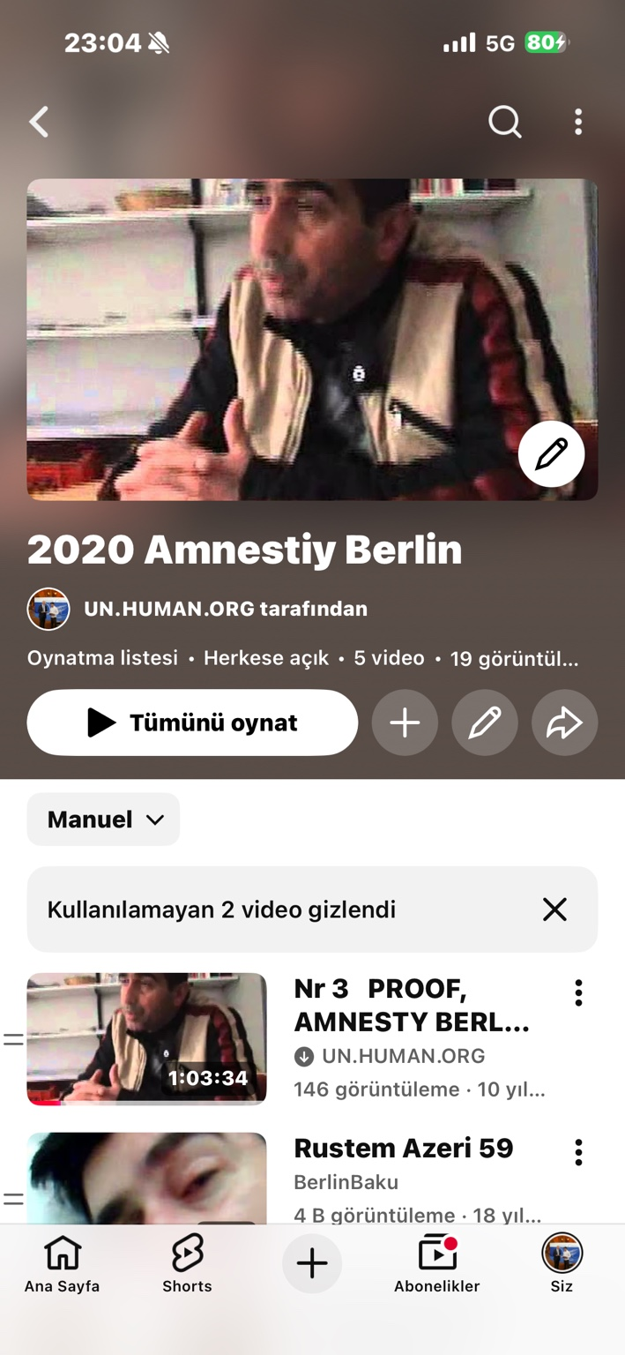
Figure 1. Applicant-provided YouTube/Amnesty Berlin screenshot preserved for Report No. 7 evidence block.
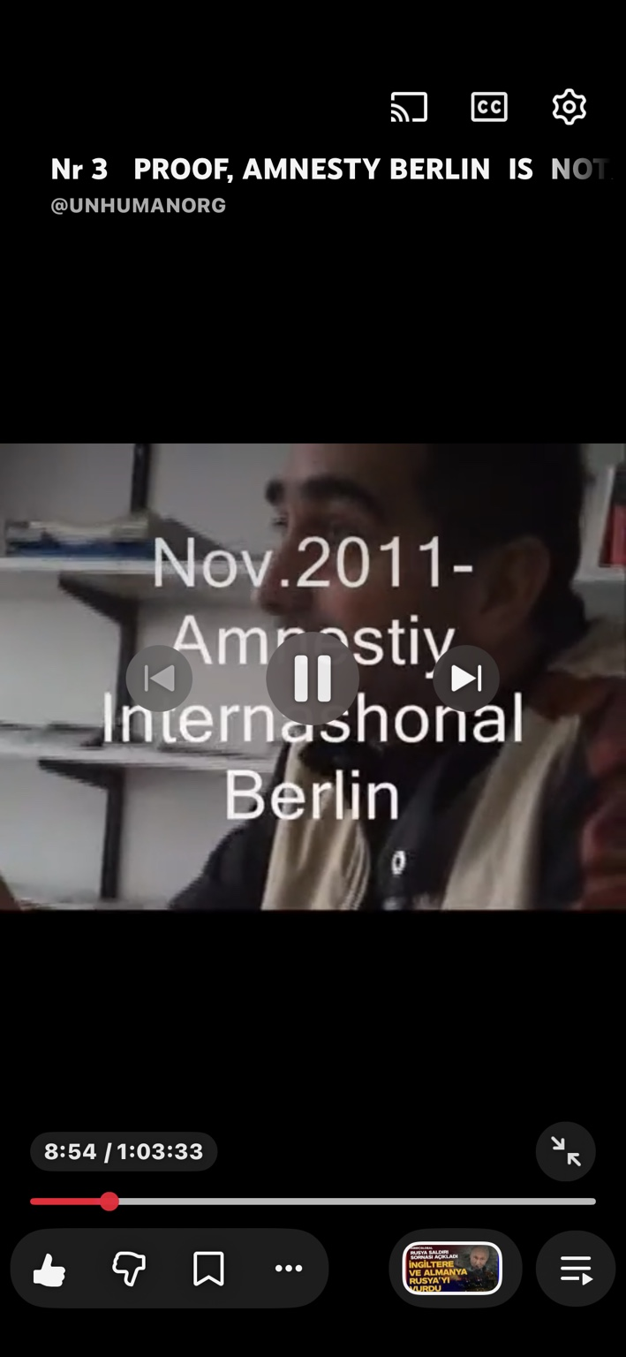
Figure 2. Applicant-provided YouTube/Amnesty Berlin screenshot preserved for Report No. 7 evidence block.
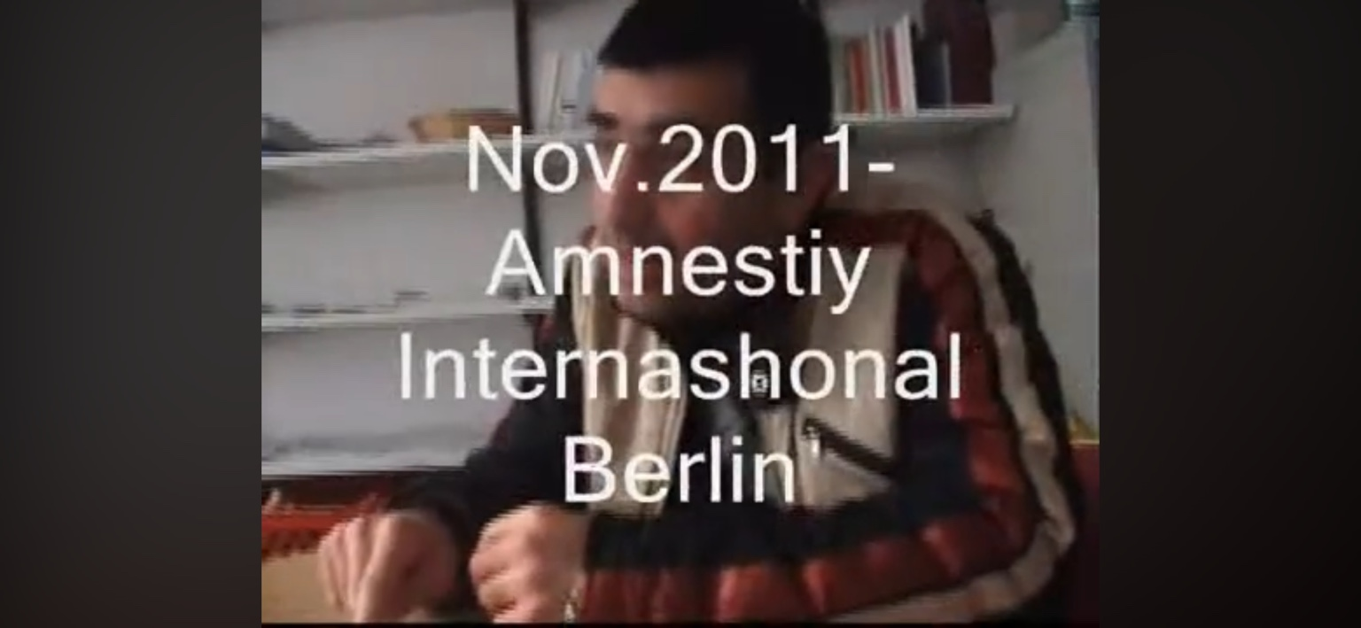
Figure 3. Applicant-provided YouTube/Amnesty Berlin screenshot preserved for Report No. 7 evidence block.

10. Legal Framework
Rome Statute Article 7 is the central international-criminal-law reference because it addresses crimes against humanity when acts are committed as part of a widespread or systematic attack directed against a civilian population, with knowledge of the attack. Article 7(1)(b) covers extermination; Article 7(2)(b) states that extermination includes intentional infliction of conditions of life, including deprivation of access to food and medicine, calculated to bring about the destruction of part of a population; Article 7(1)(k) covers other inhumane acts intentionally causing great suffering or serious injury to body or to mental or physical health. Article 7(1)(h) on persecution may also be relevant if severe deprivation of fundamental rights is linked to an identifiable group or collectivity.
The Genocide Convention / Rome Statute Article 6(c) is more restrictive and requires intent to destroy, in whole or in part, a national, ethnic, racial or religious group as such. Report No. 7 therefore uses genocide-related wording carefully: the applicant's materials require examination of whether protected-group intent can be established, but the more direct legal framework at this stage is crimes against humanity, other inhumane acts, persecution, torture, inhuman treatment and discriminatory life-destroying conditions.
ECHR Articles 2, 3, 5, 6, 8, 13 and 14 are engaged because the documented chain concerns life risk, inhuman/degrading treatment, deprivation of liberty, fair-trial problems, bodily/psychological integrity and private life, lack of effective remedy and discrimination. ICCPR Articles 6, 7, 9, 14, 17 and 26 reinforce the same analysis. CAT is engaged by allegations of detention violence, humiliation, severe suffering, psychiatric misuse, medical abandonment and complaint obstruction. CRPD is central because the applicant was officially disabled and later treated without adequate disability-based protection, access to justice, health care, independent living and protection from violence. ICESCR is relevant to social security, adequate living conditions, food/nutrition, housing and health.

11. Legal Assessment: State-Created Life-Destroying Conditions
On the applicant's documentary record, the strongest legally safe classification is not a single isolated "murder" event, but a continuous chain of state-created or state-tolerated life-destroying conditions. The chain includes detention, medical deprivation, homelessness, social and legal isolation, denial of work and subsistence, procedural barriers, compensation neutralisation, disability abandonment, evidence loss, police/prosecutorial non-protection, dental/nutrition obstruction and repeated institutional silence.
Report No. 7 must state that the applicant's case presents indicators of deliberate disablement and prolonged destruction of life. If the wider refugee/migrant suicide and self-harm pattern is confirmed by independent statistical and archival investigation, the evidence may support examination under the Rome Statute as possible crimes-against-humanity indicators, especially Article 7(1)(k) other inhumane acts and Article 7(2)(b) extermination-type conditions. The key legal question is whether the conduct was widespread or systematic, directed against a civilian population or identifiable group, and carried out pursuant to or in furtherance of state or organisational policy.
This report does not replace a criminal investigation. It states that the accumulated documentary record is strong enough to require one.

12. Retaliation / Reprisal Analysis After the UN Appeal
The applicant states that after the 15.12.2008 UN appeal and the subsequent 2009 international visibility, the situation did not improve. In his view, it became more aggressive: damages proceedings were neutralised; the EUR 91,456 burden appeared; institutional silence deepened; evidence devices later disappeared or were destroyed; violence and non-protection continued; hospitals allegedly minimised injuries; cancer/Kaposi-sarcoma and later dental/nutrition issues were not handled as life-risk matters; and the possibility of leaving Germany with stable support remained blocked.
The legally careful wording is that the applicant assesses the probability of retaliation as extremely high. The chronology requires independent investigation into possible reprisal or retaliation for his UN appeal, ECHR/Bundestag communications, press exposure, public protests and AI-assisted documentation. The report should not present retaliation as finally adjudicated without investigative access to state, court, police, hospital and institutional archives. But it must not omit the chronology: the post-UN period is central to the applicant's theory that exposure did not produce protection, but further destruction.

13. Requested Independent Investigation and Preservation Measures
- Open a full independent international investigation into the applicant's 1998-2026 documentary chain, including state, court, police, hospital, social-authority, insurer, parliamentary and NGO/institutional files.
- Require preservation of all court files, police/prosecutorial files, hospital records, psychiatric files, social/JobCenter/pension files, Bundestag/Abgeordnetenhaus petition files, embassy communications, ECHR registry materials, phone/evidence-device records, O2/provider records, and video/social-media archives.
- Conduct a statistical inquiry into suicides, suicide attempts, self-harm, psychiatric collapse, deportation-related deaths and medical/social-abandonment deaths among refugees, asylum seekers, undocumented migrants, tolerated-status persons, foreigners and vulnerable migrants in Germany for 2009-2026 and 1993-2026.
- Specifically identify recent publicly reported suicides involving young Kurdish persons from Turkey and other migrants, and compare them against police records, death registers, migration/asylum status, housing status, social-benefit records, medical contacts and institutional contacts.
- Request complete case files from Amnesty International, Berliner AIDS-Hilfe, DRK, ADB Berlin, XENION, bzfo/zfm and other organisations contacted by the applicant, including internal notes, CD/DVD inventories, correspondence, visitor logs, referral notes, refusal reasons and escalation decisions.
- Transcribe and archive the Amnesty Berlin 2011 video evidence and all related YouTube metadata, including playlist creation title/date, upload date, hidden/unavailable-video status and any modification history available from the account.
- Assess possible crimes-against-humanity indicators, including other inhumane acts, persecution and extermination-type conditions, alongside ECHR Article 2/3, CAT, ICCPR, CRPD and ICESCR violations.
- Ensure that the investigation does not convert the applicant's documentation activity into a psychiatric or credibility attack, but treats him as a witness and applicant whose materials must be preserved, indexed and examined.

14. Preliminary Findings
- The prior legal reports document a long sequence beginning in 1998-1999 detention and continuing through 2026; the case is not reducible to one social-law or dental dispute.
- The 2005 judicial correction/acquittal and compensation-entitlement chain is a central state-error anchor; the later lack of restoration and the EUR 91,456 burden require review as possible neutralisation of remedy.
- The 15.12.2008 UN appeal placed the refugee/migrant suicide pattern and the applicant's own life-risk before the United Nations before the 2009 UPR/international visibility period.
- The refugee-death documentation supports the applicant's position that suicides and self-harm among refugees/migrants were known public issues before 2009.
- The international/humanitarian organisation files show institutional notice and visible gaps in protective action; this silence requires analysis as part of the wider non-protection chain.
- The current Amnesty Berlin screenshots and YouTube link are important evidence-preservation materials and should be transcribed and archived.
- The legal threshold for final Rome Statute or genocide findings is high, but the documentary chain is serious enough to require examination under Rome Statute Article 7(1)(k), Article 7(2)(b), ECHR Articles 2 and 3, CAT, ICCPR, CRPD and ICESCR.
- The record raises a serious question whether the applicant's forced immobility - inability to safely leave Germany with pension/compensation/support despite seeking to do so - became part of a de facto life-destruction mechanism.

15. Final Conclusion
Report No. 7 concludes that the applicant's archive now presents a cumulative legal-documentary chain of exceptional seriousness. It contains documented detention and medical vulnerability, social and medical obstruction, judicial correction without restoration, compensation neutralisation, parliamentary notice, international notice, institutional silence, evidence loss, medical/dental/nutrition risk, street violence/non-protection and a broader refugee/migrant suicide context.
The strongest legal conclusion at this stage is that the matter requires independent international investigation into state-created life-destroying conditions, possible torture or inhuman/degrading treatment, disability-based abandonment, discrimination, denial of effective remedy, possible retaliation for international complaints and possible crimes-against-humanity indicators. The applicant's case should also be used as an investigative entry point into the wider question: how many refugees, foreigners and migrants in Germany between 2009 and 2026 were driven to suicide, self-harm, psychiatric collapse, disappearance or social death under conditions that were known, preventable and institutionally ignored.

